UNIVERSITY OF MAKENI

SYLVANUS KOROMA CAMPUS

YONI

Project Report on [Snake and Ladder]

**Prepared By:**

|  |  |
| --- | --- |
| Malcom Kpundeh  Edward s. Sesay  Fatmata Nabsatu Kamara | 4392  4421  4403 |
|  |  |
|  |  |
|  |  |

**Submitted to:** Mr. Musa

Date: 20th April, 2021

**ABSTRACT**

* The snake and ladders game, is a web base game using java script programming language, the objective of this snake and ladders game ,is to test the ability of our young programmers by them answering some java script question.

Table of content

Introduction

Background

Implementation

Result

Conclusion

Reference

**Introduction**

The snake and ladders game is a well upgraded game from the past snake and ladders game. It ask you a question, when ever the snake bite you, it ask you a question for you to proceed if only you have the question correct, but if No, you go back to where you came from. The question is based on java script language.  The GUI is a user friendly one and that makes it easier to play.

**Implementation**

# Snakes & Ladders

HTML5 E-Learning game on basis of Multiple Choice Questions.

This game has 5 levels and 5 different topics. By playing the game the user will definably reach in nearby point of snake and ladder. At that time a question will be asked to the user. If he/she attempts question correctly then the tick will go up with the ladder. And if attempted in correct then snake will bite and the tick will fall to the snake's tail. What are you waiting for? Let's play!

Author: [GROUP11]([https://kpundehm@gmail.com](https://kpundehm@gmail.com/))

## Browser Support- IE 10+- Chrome- Safari- Firefox

## Short Description- 5 Different Level- 5 Different Topic- Pure client side

## Configure questions Customize questions from `js/sl.config.js`. You can add many questions as you like on same level. Question will be opt from these range randomly.```

{ level:"1", theme: "animals", question: "What is JavaScript?", answers: ["client-side scripting language", "son of java", "father of python", "language"], correct: 1},

RESULT

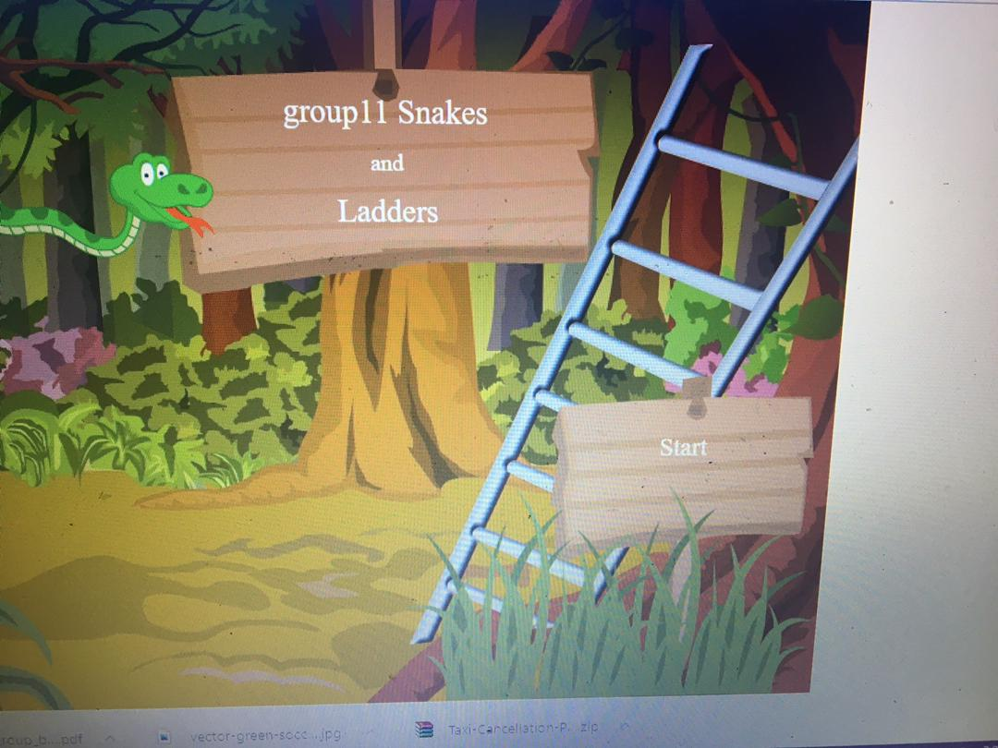

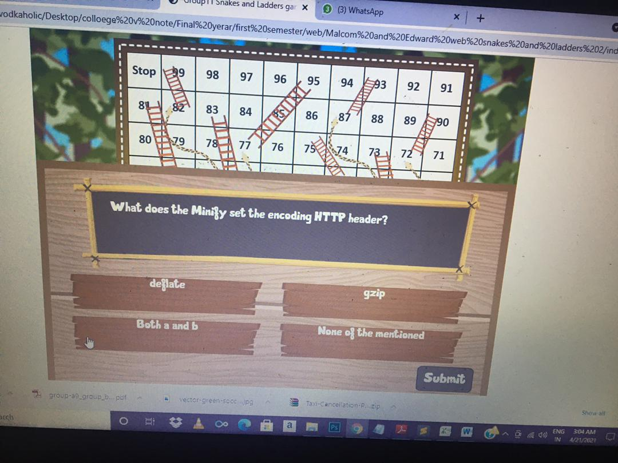

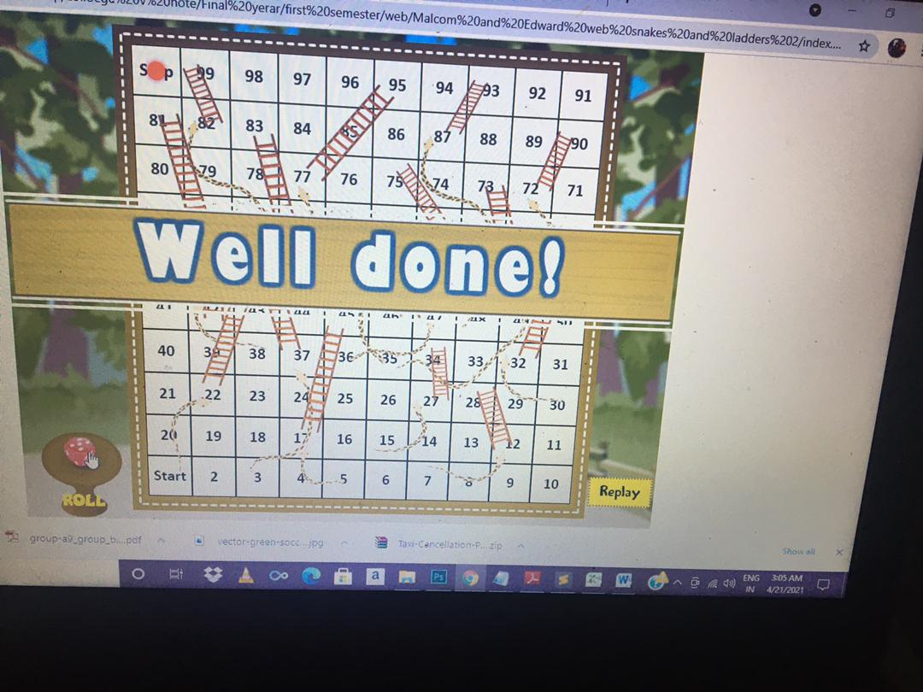

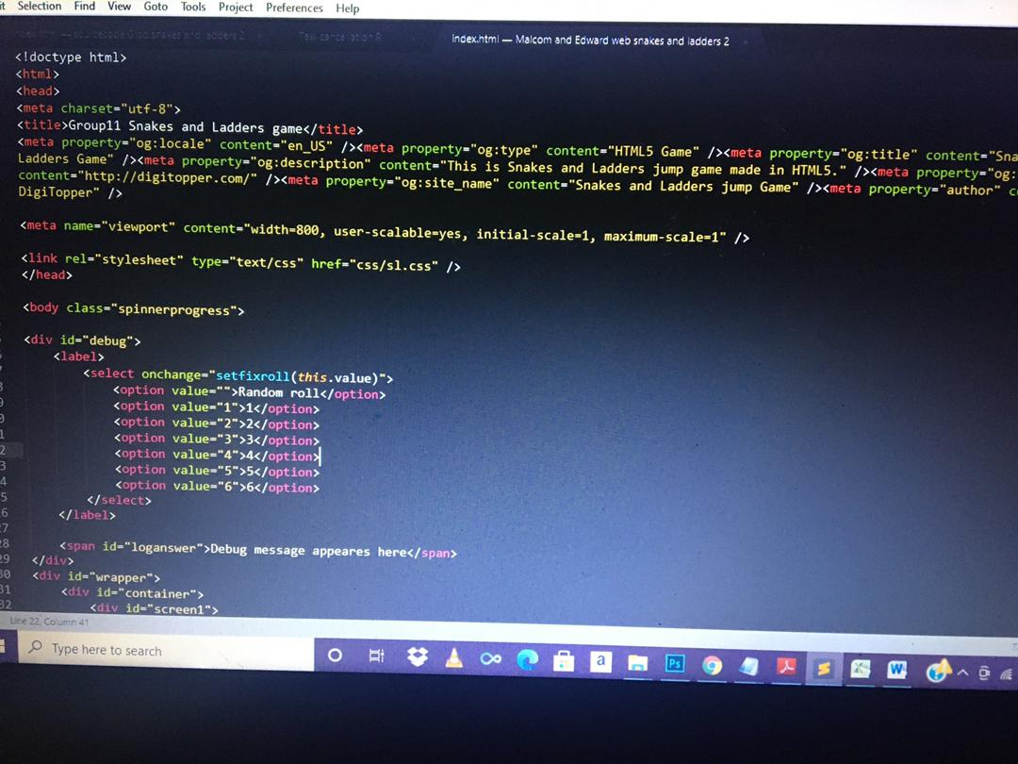

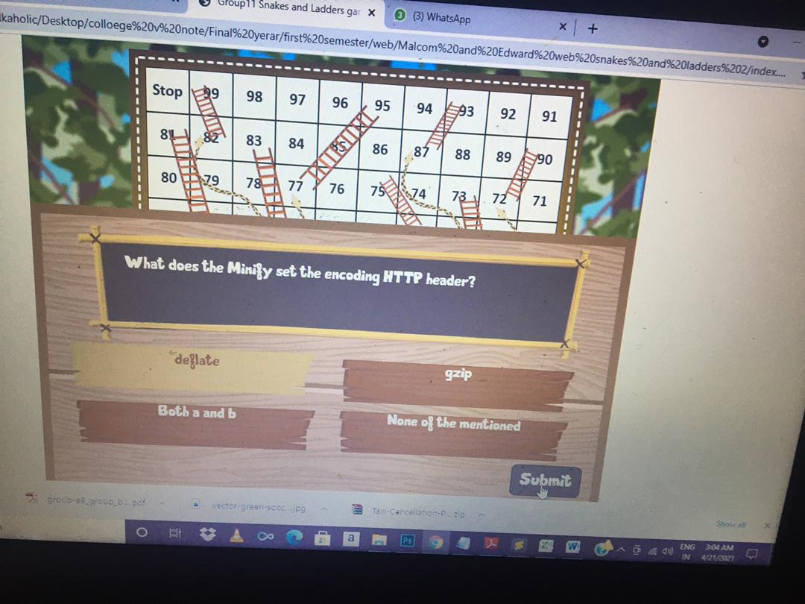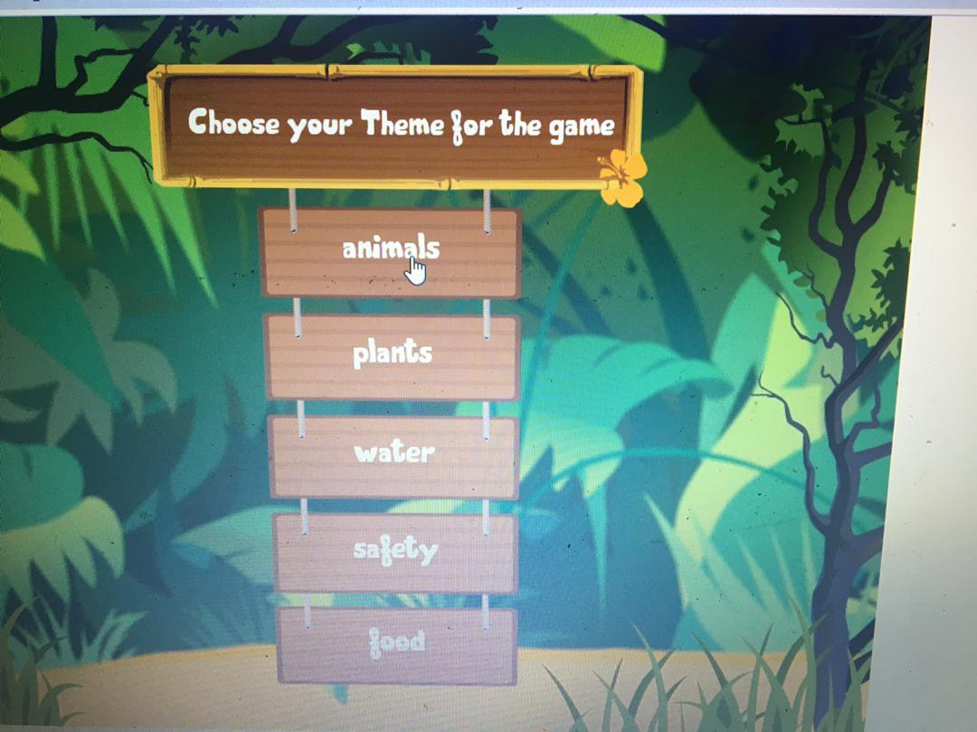

Reference

1.https://itsourcecode.com

* [www.google.com](http://www.google.com/)
* [www.greekforgreek.com](http://www.greekforgreek.com/)